Agentic AI in Banking: When Assistants Start Acting on Their Own
How financial institutions are moving from AI that answers questions to AI that completes multi-step tasks, and why the shift is testing governance as much as technology.
By early 2026, just over half of financial institutions worldwide had moved past experimentation with agentic AI, either piloting it or running it at scale (Cambridge Judge Business School, 2026). That is a notable shift for an industry that spent the previous two years mostly testing chatbots. Accenture's banking trends report for 2026 goes further, describing the year as the point where agentic AI moves from early deployment to broader use across risk management, compliance, and customer service (Accenture, as cited in Banking Dive, 2026). The technology behind this shift is not another chatbot upgrade. It is software that can plan a sequence of actions, carry them out inside real systems, and adjust when something changes, largely without a person approving each step.

The Core Shift
Generative AI tools that most banks adopted first were built to answer questions and draft text. A person still had to read the output, decide what to do, and take the next action manually. Agentic AI changes that division of labour. These systems interpret a goal, break it into steps, call the systems or tools needed to complete each step, and check the result before moving on. The scale of adoption reflects how quickly this distinction has mattered in practice. Wolters Kluwer's research, cited in an industry roundup, found that 44 percent of finance teams expected to use agentic AI in 2026, more than six times the share a year earlier (Neurons Lab, 2026). Fintech firms have moved faster than established banks, reaching more advanced adoption stages by a wide margin, which suggests the barrier is often organisational readiness rather than the technology itself (Cambridge Judge Business School, 2026).

How It Works
Stripped of vendor branding, most agentic systems in finance follow a similar loop. The agent gathers relevant data and account context, reasons about what needs to happen next, executes that step through a connected system or application interface, and then verifies the outcome before proceeding or stopping. Institutions building these systems for regulated environments log every action the agent takes, since a decision that cannot be traced back to its inputs is difficult to defend to a supervisor (Azilen, as cited in industry sources, 2026). Higher-risk or unusual cases are routed to a human reviewer rather than completed automatically, a checkpoint that most implementation guides treat as non-negotiable rather than optional.
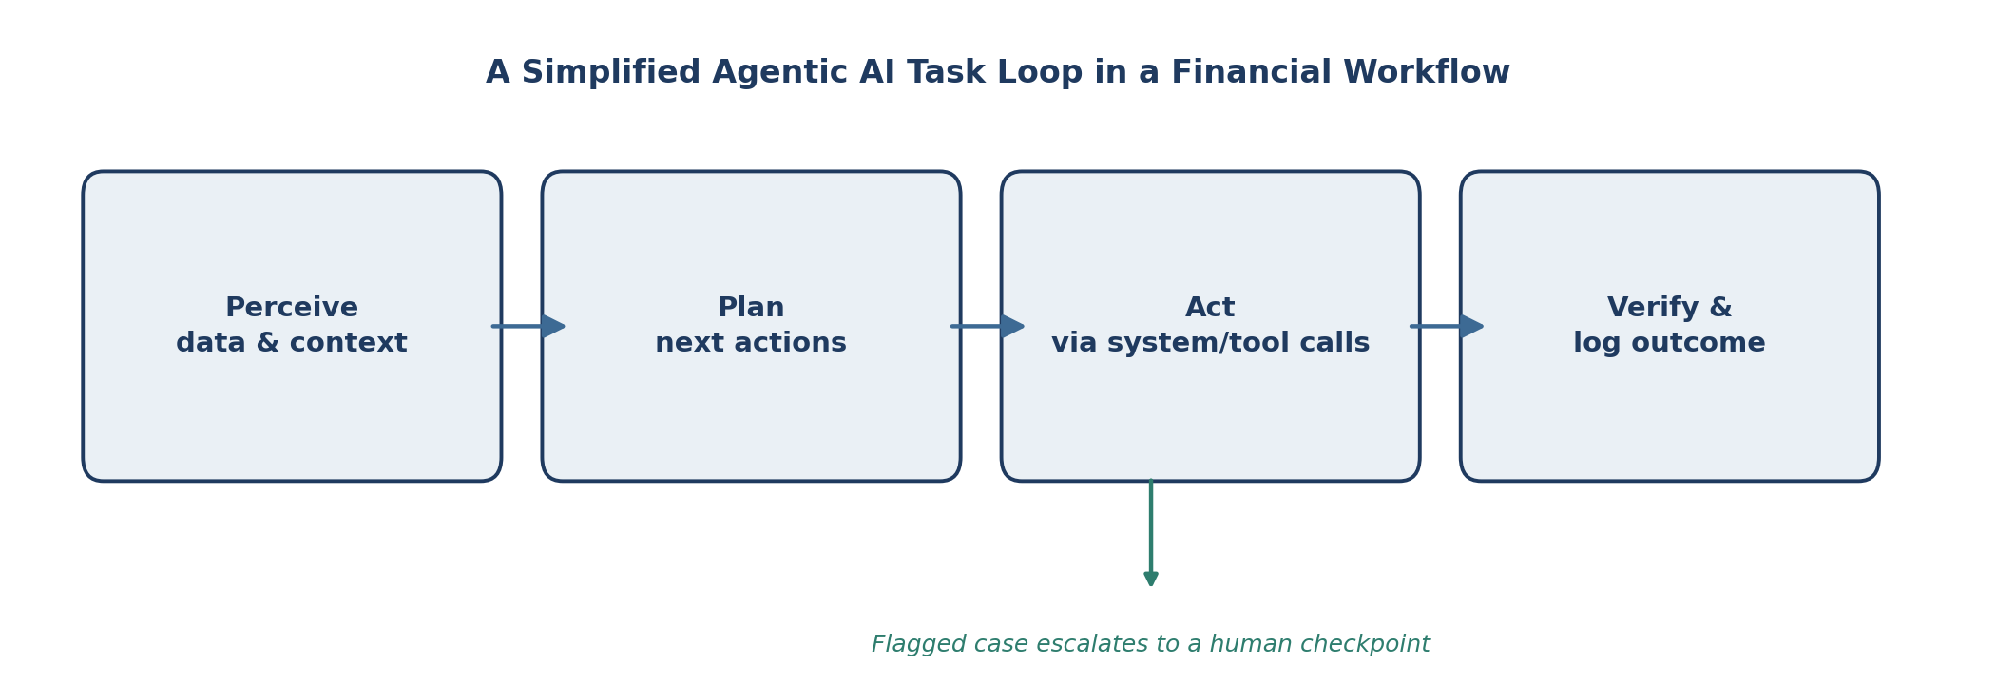
Figure 1. How an Agentic AI Workflow Executes a Financial Task
Source: Conceptual framework developed from IMF (2026) and financial services AI governance literature.
Adoption is not evenly distributed. As Figure 2 shows, nearly half of institutions surveyed in early 2026 were still exploring the technology or had not engaged with it in any structured way, while smaller groups had reached piloting or more mature scaling stages.
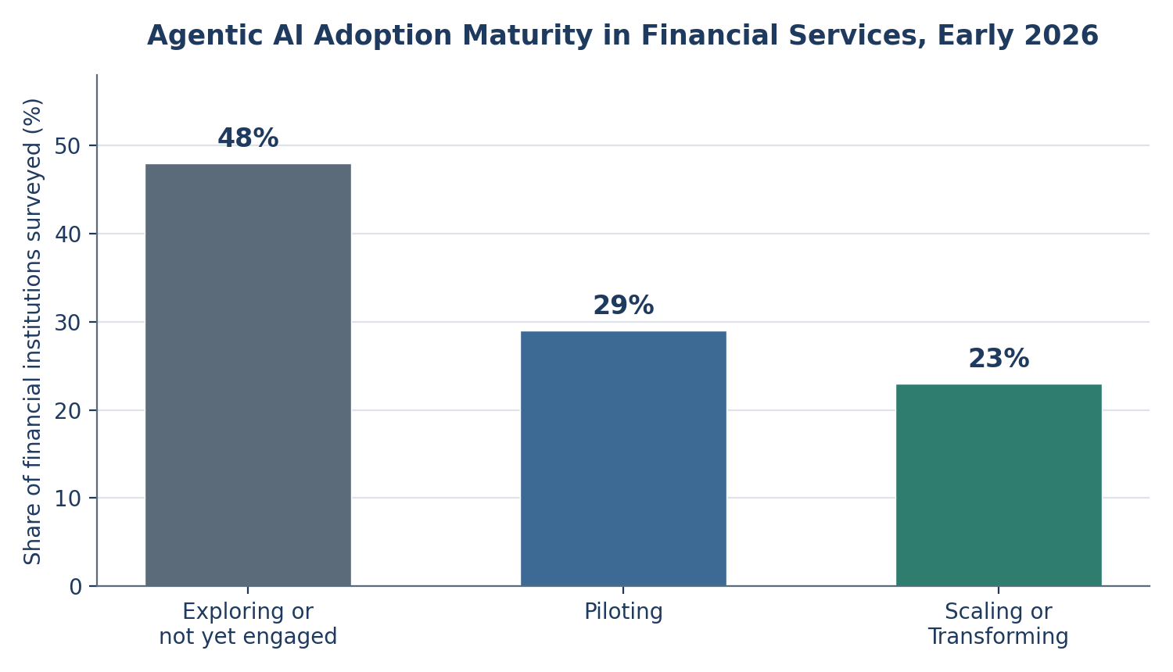
Figure 2. Agentic AI Adoption Maturity in Financial Services, Early 2026
Source: Cambridge Judge Business School, Centre for Alternative Finance (2026).

Why It Matters
For banks, the appeal is largely operational. McKinsey has estimated that AI adoption could drive up to 20 percent in net cost reductions for banks, though the firm ties much of that gain to how completely an institution becomes agentic rather than simply adding AI features (as cited in Banking Dive, 2026). For fintech companies, agentic AI is becoming a competitive differentiator, since research shows they are already ahead of incumbent banks in reaching mature adoption stages (Cambridge Judge Business School, 2026). Consumers stand to gain faster service on tasks such as account servicing and dispute resolution, which agents can execute directly rather than routing through a queue. For investors, an industry research roundup points to an average 2.3 times return on agentic AI investment within thirteen months, alongside a caution that only about 11 percent of companies have actually moved these systems into production despite far higher intentions (Neurons Lab, 2026). Regulators, meanwhile, are watching a technology that acts faster than the supervisory tools built to review it.

Risks and Limitations
The central risk is not that agentic AI fails outright, but that it fails inside an accountability gap. In the United States, revised interagency model risk guidance issued in April 2026 explicitly places generative and agentic AI outside its formal scope, even as regulators note that existing risk principles still apply (360factors, 2026). A Bank of England and Financial Conduct Authority survey found that 46 percent of firms had only a partial understanding of the AI technologies they relied on, largely because of third-party models they did not build themselves (as cited in arXiv, 2026). In the European Union, the AI Act's transparency obligations for high-risk systems take effect in August 2026, requiring traceability and human oversight for exactly the kind of multi-step automation agentic AI performs (European Commission, as cited in arXiv, 2026). Separate identity and authorisation questions are also unresolved: agents are often treated as generic service accounts rather than entities with their own auditable permissions, a gap that Singapore's Infocomm Media Development Authority and the United States' National Institute of Standards and Technology have both begun addressing through new governance frameworks in 2026 (as cited in arXiv, 2026).

What Comes Next
Momentum is unlikely to reverse. Eighty-one percent of industry respondents in the Cambridge Judge Business School survey expect agentic AI to be meaningfully deployed by 2030, making it the technology category with the clearest growth trajectory in financial services AI (Cambridge Judge Business School, 2026). Market forecasts point in the same direction: Grand View Research projects the AI agents in financial services market to grow from an estimated 691 million US dollars in 2025 to roughly 6.7 billion US dollars by 2033 (Grand View Research, 2026). What is less certain is whether governance will keep pace. A February 2026 industry framework already sets out 230 separate control objectives for financial institutions deploying AI, spanning data governance, model lifecycle, and third-party risk, which suggests the compliance burden is becoming as complex as the technology itself (Cybic, 2026).
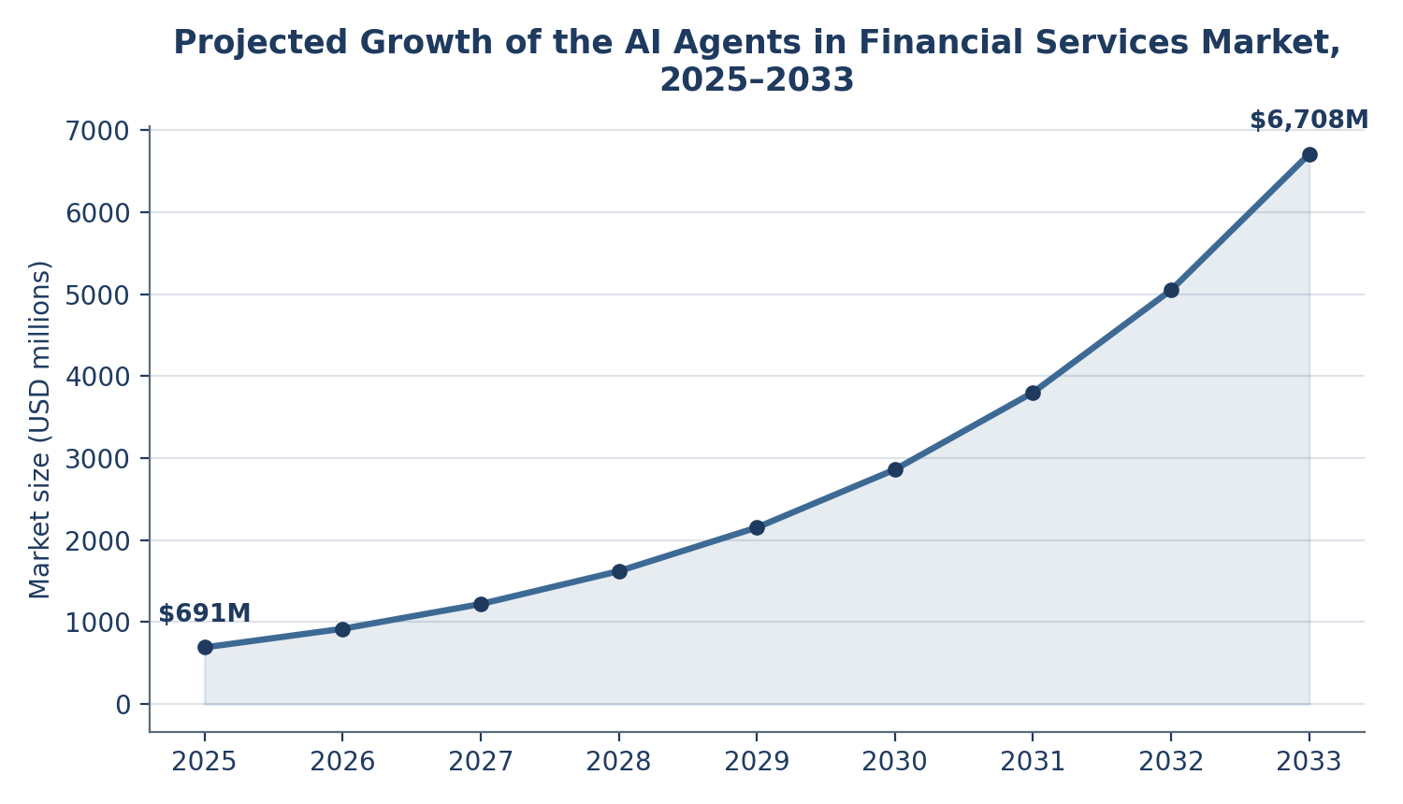
Figure 3. Projected Growth of the AI Agents in Financial Services Market, 2025–2033
Source: Grand View Research (2026).

Conclusion
The more interesting story in 2026 is not how fast agentic AI is being deployed, but how unevenly trust in it is being built. Deployment and governance are advancing on different timelines, and institutions that treat oversight, audit trails, and human checkpoints as infrastructure, rather than paperwork added after the fact, are the ones likely to scale these systems without a costly setback. The technology has already proven it can act. The industry's remaining task is proving it can be held accountable for what it does.

SEO Information
SEO Title: Agentic AI in Banking: From Copilots to Autonomy
Meta Description: How agentic AI is moving from pilots to production in financial services in 2026, and why governance and accountability are struggling to keep pace with deployment.
Primary Keyword: agentic AI in financial services
Secondary Keywords: agentic AI banking, AI agents finance, financial services AI governance, autonomous AI finance, AI regulation banking, fintech AI adoption 2026
URL Slug: /agentic-ai-financial-services-2026

References
360factors. (2026, June 29). Agentic AI updates reshaping compliance in 2026. https://www.360factors.com/blog/agentic-ai-updates/
Banking Dive. (2026, January 14). Banks aim for agentic AI scale in 2026: Report. https://www.bankingdive.com/news/banks-agentic-ai-scale-2026-accenture/809585/
Cambridge Judge Business School, Centre for Alternative Finance. (2026, May 28). 2026 global AI in financial services report: Adoption, impact and risks. https://www.jbs.cam.ac.uk/faculty-research/centres/alternative-finance/publications/2026-global-ai-in-financial-services-report/
Cybic. (2026, June 1). AI governance framework for financial services in 2026. https://cybic.ai/feeds/blog/ai-governance-financial-services-risk-2026
Grand View Research. (2026, January 27). AI agents in financial services market size, share & trends report, 2033. https://www.grandviewresearch.com/industry-analysis/ai-agents-financial-services-market-report
International Monetary Fund. (2026). How agentic AI will reshape payments (IMF Notes, Vol. 2026, Issue 004). https://www.elibrary.imf.org/view/journals/068/2026/004/article-A001-en.xml
Neurons Lab. (2026, June 21). Agentic AI in financial services: A research roundup for 2026. https://neurons-lab.com/articles/agentic-ai-in-financial-services-2026/
Trust without trusting: A recomputable trust protocol for autonomous agents. (2026). arXiv. https://arxiv.org/pdf/2605.06738

