How Data Quietly Outbid Reputation at the IPL 2026 Auction
Two uncapped debutants became the joint most expensive buy of the year. The auction's underlying numbers explain why that was not an accident.

On 16 December 2025, in a bidding room in Abu Dhabi, Chennai Super Kings paid 14.20 crore rupees each for two players who had never appeared in an IPL match. Prashant Veer and Kartik Sharma entered the auction at a base price of 30 lakh rupees and left as the joint most expensive uncapped signings in the tournament's history, a record that had stood at 10 crore rupees since 2022 (Wisden, 2025). For a franchise long nicknamed ‘Dad's Army’ for its preference for experienced campaigners, the move looked impulsive. It was not. Veer had taken nine wickets in seven matches of the Syed Mushtaq Ali Trophy, India's premier domestic T20 competition, and Kartik had scored at a strike rate above 160 in the same tournament (Business Standard, 2025). The price tag followed a pattern of domestic form, not reputation.

The Changing Game

The IPL auction has always mixed star appeal with squad planning, but the balance is shifting. Across the 2026 auction, ten franchises bought 29 overseas players for a combined 128.05 crore rupees and 48 Indian players for 87.40 crore rupees, and the majority of the Indian spend went to uncapped domestic players rather than capped internationals (Bandarupalli, 2025). Only nine capped Indian players changed hands, six of them at their base price. Meanwhile, uncapped bowler Auqib Nabi, who had taken 15 wickets at an economy under eight in the same domestic tournament, sold to Delhi Capitals for 8.4 crore rupees (Forbes India, 2025). Franchises were not simply chasing familiar names. They were pricing recent, contextual domestic performance, and doing so consistently enough to be visible in the aggregate numbers.
How It Works

Franchises do not publish their valuation models, so the mechanics behind a price like Veer's have to be inferred from public reporting and analytics research rather than read off a released formula. Research on IPL auction strategy describes a broadly consistent pipeline: domestic and T20 league performance data feeds into contextual indices, such as strike rate under pressure or death-over economy, which are converted into value bands for each playing role, which in turn set an internal price ceiling before the bidding starts (International Journal for Multidisciplinary Research, 2026). Figure 1 sets out this pipeline in simplified form.
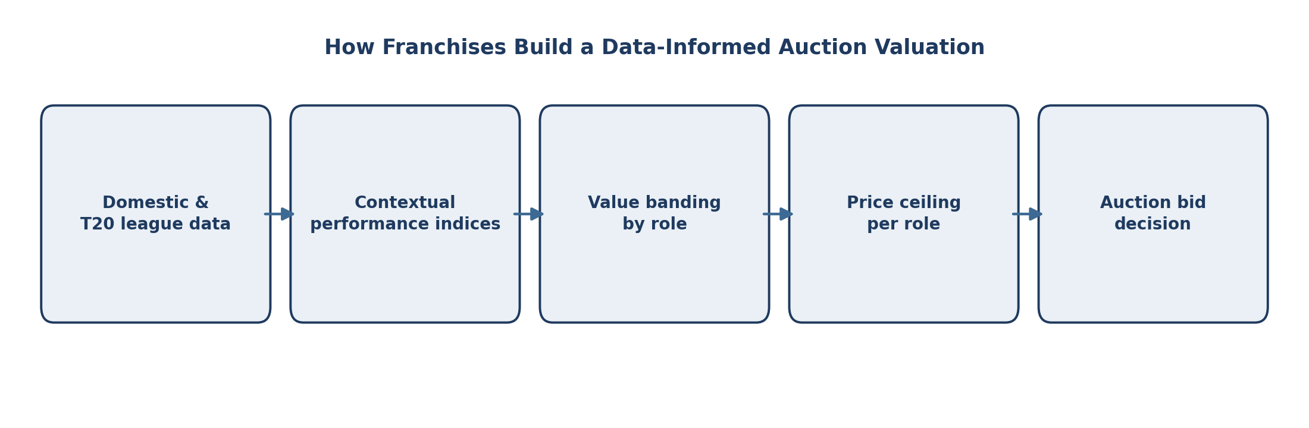
Figure 1. How Franchises Build a Data-Informed Auction Valuation
Source: Conceptual framework based on International Journal for Multidisciplinary Research (2026) and auction reporting from ESPNcricinfo.

What the Data Reveals

The auction's own numbers support this reading. Overseas players sold for an average of 4.42 crore rupees each, more than double the 1.82 crore rupee average for Indian players, a gap that reflects genuine scarcity of proven overseas death bowlers and finishers rather than pure reputation (Bandarupalli, 2025). Figure 2 sets the two totals side by side.
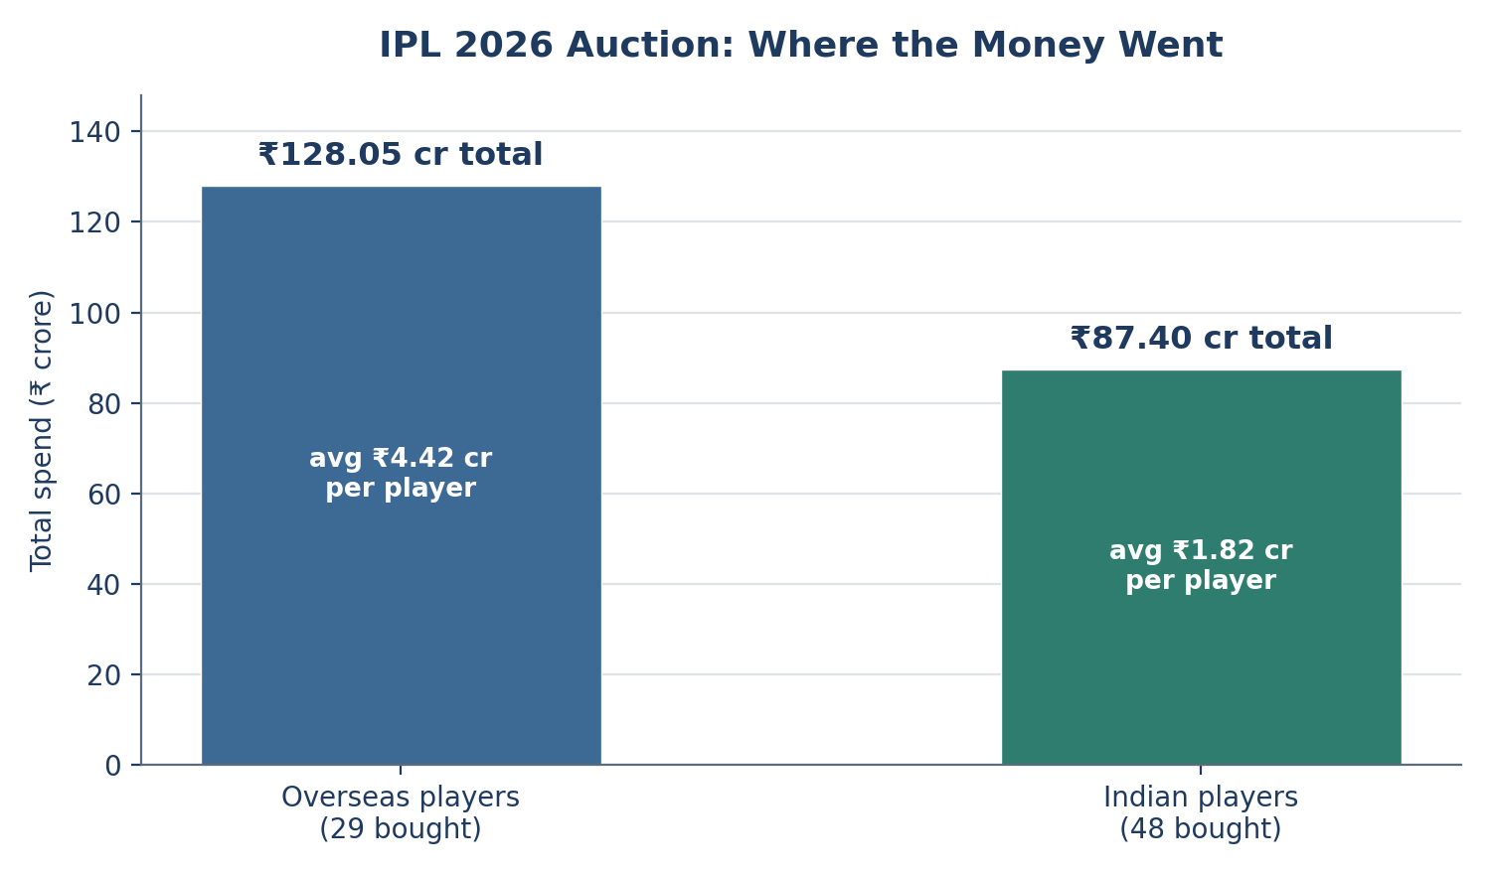
Figure 2. IPL 2026 Auction: Where the Money Went
Source: ESPNcricinfo auction data (Bandarupalli, 2025).
Age tells a related story. Thirty-two of the players bought were under 25 on auction day, and 29 of them were Indian, while only 20 players aged 30 or older were bought, just three of them Indian (Bandarupalli, 2025). Franchises were not only rewarding current form. They were pricing in a longer runway of contracted seasons, which only makes sense if a team believes its data can identify young players likely to sustain that form rather than fade after one good tournament.
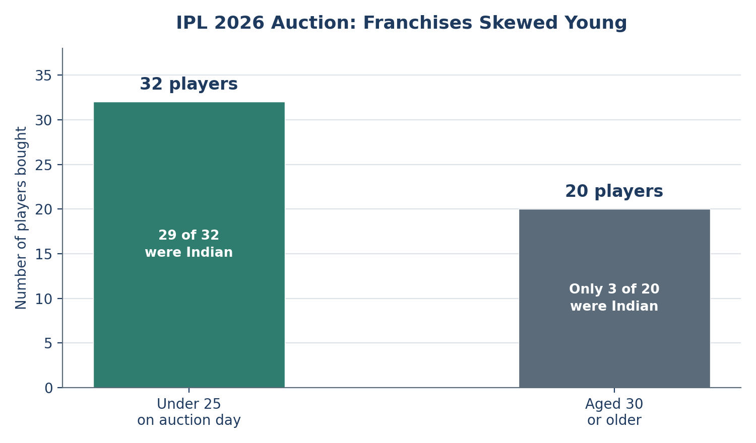
Figure 3. IPL 2026 Auction: Franchises Skewed Young
Source: ESPNcricinfo auction data (Bandarupalli, 2025).

Impact on Athletes, Teams and Fans

For domestic players, the shift changes what gets rewarded. A strong SMAT season can now outweigh years of quiet league cricket, which raises the stakes of every performance in a way that international recognition once buffered. For franchises, analytics units are gaining a louder voice in team-building decisions that used to sit mostly with head coaches and chief scouts, though most organisations still describe the process as a partnership between data and scouting judgement rather than a handover (International Journal for Multidisciplinary Research, 2026). For fans and broadcasters, the auction itself has become a data story worth following in its own right, with pre-auction valuation models and post-auction spend breakdowns now a fixture of cricket media coverage. Sponsors, in turn, gain more predictable rosters, since teams built around identified value bands tend to change shape less dramatically from one season to the next.

The Risks and Limitations

Caution is warranted before crediting data with more than it has earned. No franchise has made its valuation model public, so the pipeline in Figure 1 is inferred from outcomes and industry commentary rather than confirmed directly. Domestic-form indices also carry a real risk of overweighting a single hot tournament, since one excellent SMAT campaign is a small sample against a full career. Access to detailed performance data is not evenly spread across India's domestic structure either, which can mean players from better-tracked state associations are more visible to analytics teams than equally talented players elsewhere. And figures like strike rate under pressure cannot capture temperament, dressing-room fit, or a player's response to sudden wealth and expectation, all of which experienced scouts and coaches still weigh heavily in practice.

What Comes Next

The clearest trend is that domestic T20 data is being captured and used more systematically each auction cycle, and reporting suggests this will continue as more state associations digitise their tournaments (International Journal for Multidisciplinary Research, 2026). What is less certain, based on current evidence, is whether teams that lean most heavily on these models will actually win more titles. Cost-per-value comparisons across past mega auctions exist, but a title correlation over one or two seasons is not yet a settled finding, and the 2026 season itself will be the first real test of whether CSK's shift in strategy pays off on the field rather than only in the auction room.

Conclusion

The real story of the 2026 auction is not that data replaced reputation. Reputation still mattered, and star overseas all-rounders still commanded the highest prices in the room. What changed is that data now sets the reserve price reputation has to clear. Two uncapped players with no international caps and no highlight reel beyond a few weeks of domestic cricket became the second most expensive purchase of the day, not because a franchise gambled, but because a spreadsheet somewhere in Chennai had already decided they were worth the bid.


References

Bandarupalli, S. (2025, December 16). IPL 2026 auction: KKR spend big, CSK break from tradition, MI and PBKS have a quiet time of it. ESPNcricinfo. https://www.espncricinfo.com/story/ipl-2026-auction-kkr-spend-big-csk-break-from-tradition-mi-and-pbks-have-a-quiet-time-of-it-1515945
Business Standard. (2025, December 16). IPL 2026 auction highlights: Top overseas & uncapped players, full list of sold and unsold players. https://www.business-standard.com/cricket/ipl/ipl-2026-auction-indian-premier-league-mini-auction-cameron-green-highest-bid-uncapped-players-sold-ipl-auction-key-moments-125121600378_1.html
ESPNcricinfo. (2025, December 13). IPL auction 2026 FAQs: When, where, who and how much. https://www.espncricinfo.com/story/ipl-auction-2026-faqs-when-where-who-and-how-much-1515453
Forbes India. (2025, December 17). IPL auction 2026: Uncapped players hit it out of the park. https://www.forbesindia.com/article/news/ipl-auction-2026-uncapped-players-hit-it-out-of-the-park/2989496/1
International Journal for Multidisciplinary Research. (2026). How data analytics has transformed player selection in the IPL. https://www.ijfmr.com/papers/2026/1/67546.pdf
Sportskeeda. (2025, December 16). Top 5 most expensive uncapped players in IPL history ft. Prashant Veer. https://www.sportskeeda.com/cricket/top-5-expensive-uncapped-players-ipl-history-ft-prashant-veer
Wisden. (2025, December 18). Most expensive uncapped players in each IPL auction: Where are they now? https://www.wisden.com/series/ipl-2026/cricket-news/most-expensive-uncapped-players-in-each-ipl-auction-where-are-they-now

