Pharmaceutical Industry Research Report
Dr. Reddy's Laboratories and Polpharma Group
Prepared by: Silvy S. Nag
Report date: July 23, 2026
"Recent Developments" reflects the 12 months preceding the report date (July 2025 - July 2026) unless otherwise noted.
This report profiles two pharmaceutical manufacturers - Dr. Reddy's Laboratories (India) and Polpharma Group (Poland) - covering their company overview, API portfolio, manufacturing footprint and regulatory standing, recent developments, and competitive landscape. Information was compiled from company websites and press releases, regulatory filings (SEC/USFDA), and reputable industry and financial publications; sources are listed at the end of the report with access dates.

1. Dr. Reddy's Laboratories

1.1 Company Overview
Headquarters | Hyderabad, Telangana, India (U.S. operations headquartered in East Brunswick, New Jersey)
Listing | BSE: 500124; NSE: DRREDDY; NYSE: RDY (American Depositary Shares)
Founded | 1984, by Kallam Anji Reddy
Approx. annual revenue | About $3.8-3.9 billion (₹32,554 crore) for FY2025, the year ended March 31, 2025 - a record year, up roughly 17% year-on-year, with EBITDA surpassing $1 billion for the first time
Employees | Approximately 27,500
Business focus
Dr. Reddy's is an integrated global pharmaceutical company organized around three businesses: Global Generics (branded and unbranded generics, biosimilars, and over-the-counter products), Pharmaceutical Services and Active Ingredients (APIs and custom pharmaceutical services), and Proprietary Products. It markets medicines in gastroenterology, cardiovascular disease, diabetology, oncology, pain management, and dermatology across more than 25 markets, with the United States, India, Russia/CIS, and Europe as its largest regions.
Key strengths
- Financial resilience: record FY2025 revenue and EBITDA, a net cash surplus balance sheet, and one of the stronger credit profiles among global generics peers.
- Broad, complex API and generics portfolio: one of the world's largest API suppliers, offering 250+ APIs to customers in 80+ countries, with particular depth in complex molecules (steroids, peptides, HPAPIs).
- Growing biosimilars and complex-generics pipeline: an expanding slate of partnered biosimilars (oncology, bone health, immunology) and first-to-market complex generic launches, such as generic Bosutinib in the U.S. in June 2026.
- Geographic diversification: strong and growing presence in Europe (aided by the acquired nicotine-replacement-therapy business) and emerging markets, reducing reliance on any single market.
Key weaknesses
- Recurring manufacturing-compliance findings: the company has received multiple USFDA Form 483 observation letters at Indian facilities over the past 12 months (Srikakulam, Miryalaguda, and the Bachupally biologics site), which can delay product approvals, particularly for biosimilars.
- U.S. generics price erosion: increased competition and pricing pressure on key products such as generic Revlimid (lenalidomide) have weighed on North America segment revenue.
- No U.S. manufacturing base: management has confirmed it is not currently building U.S. manufacturing capacity, leaving the company exposed to potential tariff or trade-policy risk on pharmaceutical imports.
Growth strategy
Dr. Reddy's strategy centers on shifting its mix toward higher-margin complex generics, biosimilars, and specialty/branded products, while pursuing bolt-on acquisitions and licensing deals to add differentiated assets (for example, the STUGERON brand acquisition and the Progynova/Cyclo-Progynova trademark purchase) and expanding its biosimilars pipeline through partnerships with companies such as Alvotech, Bio-Thera Solutions, Coya Therapeutics, and Sam Chun Dang Pharm.

1.2 API Portfolio
Through its Pharmaceutical Services and Active Ingredients (PSAI) business, Dr. Reddy's is recognized as one of the largest API suppliers in the world, offering more than 250 active pharmaceutical ingredients to generic and innovator drug manufacturers in over 80 countries. Its API capabilities include complex chemical synthesis, highly potent APIs (HPAPIs), peptides, carbohydrates, prostaglandins, and steroids, supported by a digital customer platform (XCEED) for order management.
- Key therapeutic areas served: gastrointestinal, cardiovascular, diabetology, oncology, pain management, dermatology, anti-infectives, central nervous system, and pediatrics.

1.3 Manufacturing Footprint
Dr. Reddy's manufacturing base is concentrated in India, supplemented by facilities in Mexico and the United Kingdom. Historically, the company has operated 8 USFDA-inspected facilities - 6 in India and one each in Mexico and the UK - alongside formulation plants supplying a range of dosage forms. Key sites referenced in recent regulatory activity include the API plant at Miryalaguda (CTO-5), the formulations facility at Srikakulam, and the biologics manufacturing site at Bachupally, Hyderabad.
- Key regulatory approvals/oversight: facilities are inspected by USFDA, and the company's international manufacturing and marketing network also engages with EMA and WHO-GMP standards, among other regional regulators. Inspection outcomes over the past year have been mixed:
  - May 2025 - USFDA GMP inspection at the Miryalaguda API plant (CTO-5) closed with a Form 483 citing two observations.
  - July 2025 - USFDA GMP/Pre-Approval Inspection at the Srikakulam formulations plant resulted in a Form 483 with seven observations.
  - December 2025 - a further USFDA inspection at Srikakulam produced a Form 483 with five observations; the inspection was subsequently closed in March 2026 with a favorable Voluntary Action Indicated (VAI) classification.
  - June 2026 - a USFDA Pre-License Inspection of the Bachupally, Hyderabad biologics facility (tied to the company's biosimilars pipeline) resulted in a Form 483 with seven observations, a repeat finding following five observations in a September 2025 inspection of the same site.
A Form 483 lists an inspector's observations and is not, by itself, a final FDA determination on GMP compliance; companies are given time to respond and remediate.
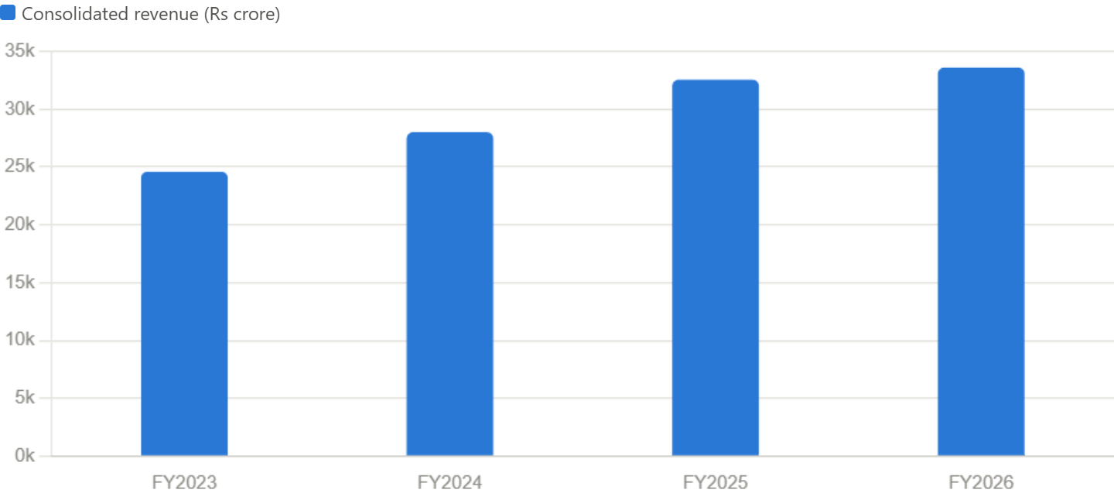
Chart 1: Consolidated revenue, FY2023–FY2026. Figures come from the company's own quarterly/annual earnings releases as filed with the SEC (Form 6-K): FY2023 ₹24,588 crore (May 2023 release), FY2024 ₹28,011 crore, FY2025 ₹32,554 crore (May 2025 release, up 17% YoY), and FY2026 ₹33,593 crore (May 2026 release, up 3.2% YoY, the year growth flattened notably due to U.S. generic price erosion).

1.4 Recent Developments (last 12 months)
- Business development and licensing: acquired the STUGERON brand (an anti-vertigo product) from Janssen Pharmaceutica, an affiliate of Johnson & Johnson, for about $50.5 million, covering 18 markets across Asia-Pacific, Europe, the Middle East, and Africa (September 2025); acquired the Progynova and Cyclo-Progynova trademarks for the Indian market from Mercury Pharma Group, marking its entry into hormone replacement therapy in India, for roughly $32 million (February 2026); and signed an exclusive distribution and licensing agreement with Innoviva Specialty Therapeutics for XACDURO across Latin America, Russia, and other CIS markets (June 2026).
- Biosimilars partnerships: expanded its biosimilars pipeline through agreements with Bio-Thera Solutions for two proposed biosimilars (a Stelara biosimilar, BAT2206, and a Simponi biosimilar, BAT2506) targeting Southeast Asia and Colombia, and continued collaboration with Alvotech on a proposed pembrolizumab biosimilar; the FDA accepted a Biologics License Application for AVT03 (a proposed denosumab biosimilar) developed with a partner, though the company's Swiss arm subsequently received a Complete Response Letter for AVT03 in December 2025.
- Product launches: achieved the first-to-market U.S. launch of generic Bosutinib 400mg tablets (equivalent to Pfizer's oncology drug Bosulif) in June 2026, developed with MSN Laboratories, securing 180 days of generic exclusivity; also launched generic Semaglutide in Canada in May 2026.
- Manufacturing and portfolio actions: discontinued development of a conjugated-estrogen product at its Middleburgh, New York site following technical challenges, recording a modest net loss on the wind-down; divested its membership interest in the Dr. Reddy's Laboratories Louisiana LLC subsidiary; and expanded a long-acting injectable and liposomal-formulation partnership with South Korea's Sam Chun Dang Pharm to include liposomal Amphotericin B and Irinotecan.
- Regulatory/compliance activity: multiple USFDA facility inspections and Form 483 observations across Indian sites, as detailed in Section 1.3, representing an ongoing area for investors and regulators to monitor, particularly given the biologics unit's role in the company's biosimilars growth strategy.

1.5 Competitors
- Sun Pharmaceutical Industries (India): India's largest pharmaceutical company by revenue and market capitalization; competes directly in the Indian branded-generics market and in U.S. generics/specialty products, with heavier R&D investment in specialty medicines.
- Cipla (India): a major rival in respiratory, HIV/AIDS, and pediatric therapeutics, with a comparable export-driven, U.S.-facing generics business.
- Aurobindo Pharma (India): competes closely in generics and APIs, leveraging manufacturing scale for aggressive pricing that pressures margins across the industry, including Dr. Reddy's.
- Lupin and Zydus Lifesciences (India): overlapping generics and biosimilars portfolios and similar regulated-market (U.S./EU) manufacturing footprints.
- Natco Pharma (India): a direct competitor in oncology generics, notably around lenalidomide (generic Revlimid), a product line important to Dr. Reddy's North America revenue.
- Teva Pharmaceutical Industries (Israel), Sandoz (Switzerland), and Viatris (U.S.): the leading global generics manufacturers; all three compete with Dr. Reddy's for share in U.S. and European generics and are simultaneously expanding into complex generics and biosimilars, intensifying competition in the same growth segments Dr. Reddy's is targeting.
- Biocon Biologics (India): a key rival in the biosimilars space, where both companies are racing to secure regulatory approvals and commercial partnerships for oncology and immunology biosimilars.
- 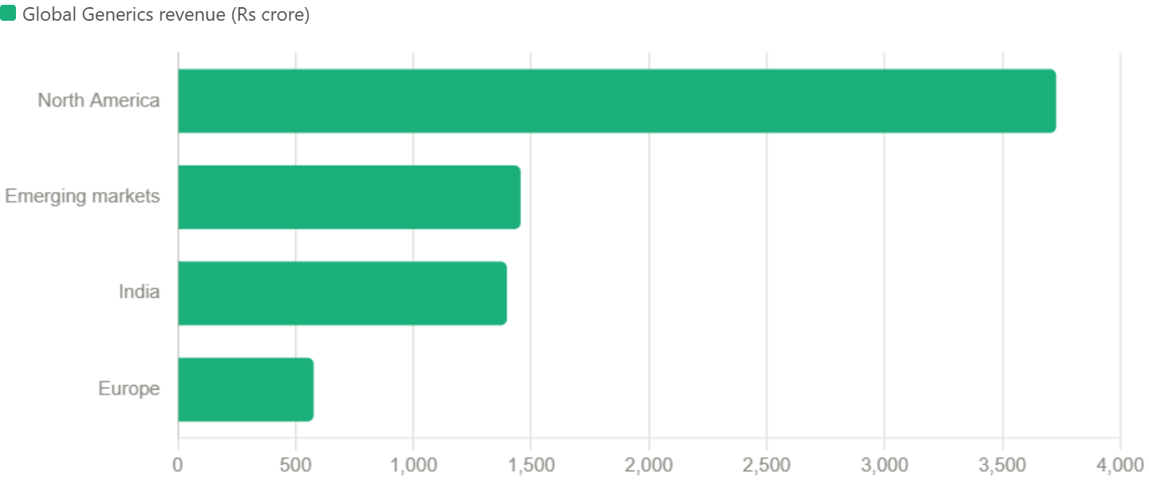
- Chart 2: Global Generics revenue by region, Q2 FY2025 (quarter ended September 30, 2024). Sourced from Dr. Reddy's official Q2 FY25 results as reported by Business Standard (November 2024): North America ₹3,728.1 crore (+17% YoY, largest single market), Emerging Markets ₹1,455.4 crore, India ₹1,397.1 crore, and Europe ₹577 crore. This shows how dependent Dr. Reddy's remains on the U.S., which is also where it faces the most price erosion and USFDA scrutiny.

2. Polpharma Group

2.1 Company Overview
Headquarters | Polpharma Group B.V. (holding company) is headquartered in Amsterdam, Netherlands; its principal manufacturing subsidiary, Zakłady Farmaceutyczne Polpharma S.A., is headquartered in Starogard Gdański, Poland
Founded | 1935, in Starogard Gdański, Poland
Ownership | Privately held (not publicly listed); as a private company it does not publish the detailed financial disclosures typical of listed peers
Approx. annual revenue | More than EUR 1.3 billion annually, per the company's own reporting (third-party data aggregators cite a wide range of figures, from roughly $750 million to $1.5 billion, likely reflecting different corporate entities within the group or differing conversion/reporting periods - treat only the company's own figure as authoritative)
Employees | Approximately 6,200 across the group
Business focus
Polpharma Group is one of the largest pharmaceutical groups in Central and Eastern Europe, the Caucasus, and Central Asia, and the leading pharmaceutical manufacturer in Poland. It operates across the value chain - from active pharmaceutical ingredient synthesis to finished-dose manufacturing - producing prescription and over-the-counter medicines, hospital drugs, dietary supplements, and medical devices. Its biosimilars arm, Polpharma Biologics, develops and licenses biosimilar monoclonal antibodies globally, while its API division, Polpharma API, operates as a contract development and manufacturing organization (CDMO) alongside supplying its own finished-dose business. Core therapeutic areas span cardiology, gastroenterology, neurology, pulmonology, anti-infectives, dermatology, and ophthalmology.
Key strengths
- Regional market leadership: the leading pharmaceutical producer in Poland and a leading player in Kazakhstan, with roughly 90 years of brand heritage and manufacturing experience in the region.
- Vertical integration: in-house API synthesis feeding its own finished-dose manufacturing, including a dedicated high-potency API (HPAPI) center ('Prometheus') for oncology-related substances - a capability few Central European manufacturers can match.
- An increasingly credible global biosimilars business: Polpharma Biologics has secured FDA and EMA acceptances and international commercialization partnerships (with Teva, Bioeq/Zydus, and Libbs Farmacêutica) for biosimilars including natalizumab (Tyruko, the first biosimilar for multiple sclerosis), ranibizumab, and a proposed ocrelizumab biosimilar.
- Forward investment in advanced modalities: a newly launched RNA-based medicines manufacturing platform, positioning the company in a higher-growth therapeutic category beyond traditional small-molecule generics.
Key weaknesses
- Limited public financial disclosure: as a private company, Polpharma's consolidated financials are not independently auditable by outside analysts to the same degree as listed peers, and third-party revenue estimates vary considerably.
- Smaller global scale: compared with Teva, Sandoz, or Sun Pharmaceutical Industries, Polpharma's core generics business remains regionally concentrated in CEE/CIS markets, which are typically lower-margin and more exposed to currency and macroeconomic volatility than Western Europe or the U.S.
- Geopolitical and regional exposure: significant historical operations in Kazakhstan and other CIS markets carry geopolitical and currency risk relative to Western European or U.S.-focused peers.
Growth strategy
Polpharma is pursuing growth through regional M&A (most notably the 2026 acquisition of Romania's Biofarm), continued investment in advanced manufacturing platforms (HPAPI and RNA-based medicines), expansion of its Central Asian manufacturing base (the SANTO plant in Kazakhstan), and global licensing partnerships that let Polpharma Biologics monetize its biosimilar pipeline through established commercial partners such as Teva, rather than building out its own worldwide sales infrastructure.

2.2 API Portfolio
Polpharma API is the largest active pharmaceutical ingredient manufacturer in Poland, producing roughly 41 substances on a commercial scale, of which about 19 are vertically integrated into the company's own finished-dose medicines (including sildenafil, piracetam, pentoxifylline, metronidazole, and hydrochlorothiazide). Most production takes place at the Starogard Gdański site, supplemented by a smaller API plant in Warsaw. The division also operates as a CDMO, supporting external pharmaceutical customers with process development, scale-up, and cGMP manufacturing of small-molecule APIs, and has recently added dedicated capacity for highly potent APIs (HPAPIs) used in oncology and other specialty treatments.
- Key therapeutic areas served: cardiology, gastroenterology, neurology, pulmonology, anti-infectives, dermatology, and ophthalmology, with newer capabilities emerging in oncology-related HPAPIs and RNA-based active substances.

2.3 Manufacturing Footprint
The group operates 5 manufacturing plants and 3 research and development centers. Its largest site, in Starogard Gdański, Poland, is one of the largest pharmaceutical factories in Europe and the country's only large-scale API plant, alongside a newer HPAPI facility. The group also operates the SANTO plant in Shymkent, Kazakhstan - with capacity for roughly 1.2 billion tablets and 300 million ampoules/vials per year - which has received cumulative investment of about $108 million since 2011, rising toward $130 million by 2026, and has positioned Kazakhstan as a regional pharmaceutical manufacturing hub.
- Key regulatory approvals: the Starogard Gdański API plant has passed a series of USFDA inspections (2004, 2009, 2012, 2015, and 2018) with positive outcomes, and manufacturing is carried out under cGMP and FDA-compliant standards. Product documentation is prepared to EDQM (Certificate of Suitability), EU DMF, and US DMF requirements, reflecting alignment with European and U.S. regulatory frameworks.
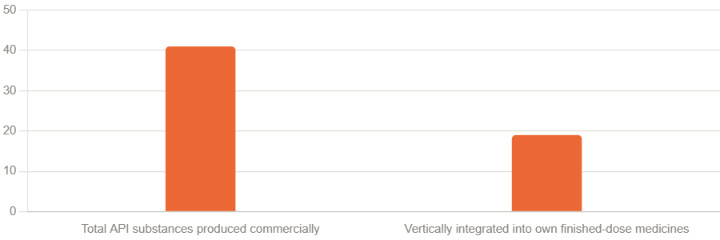
Chart 1: API portfolio composition. Sourced from Polpharma's official website (polpharma.pl): the company produces 41 active pharmaceutical ingredients at commercial scale, mostly at its Starogard Gdański plant, of which 19 are vertically integrated, meaning Polpharma uses them internally to make its own finished-dose medicines rather than only selling them externally as APIs.

2.4 Recent Developments (last 12 months)
- Leadership transition: Polpharma Group announced a planned leadership change, with Sebastian Szymanek appointed President/CEO (announced October 2025).
- Acquisition of Biofarm (Romania): Polpharma signed an implementation agreement in May 2026 with Longshield Investment Group and Lion Capital (which together held about 88.4% of Biofarm) to acquire Biofarm, a leading Romanian pharmaceutical manufacturer, through a voluntary takeover bid valued at approximately EUR 270 million (about RON 1.36 billion). The transaction completed in July 2026, with Polpharma's CEO and CEE regional General Manager joining Biofarm's board - one of the largest pharmaceutical M&A transactions in Romania's history and a clear step in Polpharma's regional expansion strategy. Biofarm reported 2025 revenue of RON 319 million and had 369 employees at the time of the deal.
- RNA-based medicines platform: in May 2026, Polpharma launched a PLN 238.7 million investment project in Starogard Gdański to build a complete RNA-based medicines value chain in Poland - from API synthesis through process development and analytics to finished-product manufacturing - aimed at reducing Poland's reliance on imported advanced therapeutics.
- Polpharma Biologics - global licensing and pipeline progress: signed a global licensing agreement with Teva Pharmaceutical Industries (announced July 9, 2026) for a proposed ocrelizumab biosimilar (candidate PB018, referencing Roche's Ocrevus for multiple sclerosis), covering intravenous and subcutaneous formulations across the U.S., EU, Canada, Australia, Brazil, Israel, New Zealand, and Turkey, with Polpharma retaining development and manufacturing responsibility and Teva handling regulatory submissions and commercialization. Shortly after, Polpharma Biologics partnered with contract research organization PSI CRO (June 2026) to run a Phase I trial of PB018, expected to begin in October 2026 with about 222 participants.
- Other biosimilars milestones (late 2025): confirmed the U.S. launch of Tyruko (natalizumab), the first biosimilar approved for multiple sclerosis, developed with partner Sandoz (November 2025); launched Ranivisio PFS, Europe's first pre-filled-syringe presentation of a ranibizumab biosimilar (October 2025); signed a licensing agreement with Brazil's Libbs Farmacêutica for an autoimmune-disease biosimilar (December 2025); and was dismissed as a defendant (January 2026) from ongoing U.S. patent litigation brought by Biogen over natalizumab, narrowing the remaining legal exposure tied to that product.

2.5 Competitors
- Teva Pharmaceutical Industries and Sandoz: both compete with Polpharma in European generics while also serving as commercialization partners for several of Polpharma Biologics' biosimilar candidates - an example of the generics/biosimilars industry's frequent overlap between rival and partner.
- Zentiva and Krka: close regional competitors with comparable Central and Eastern European generics manufacturing and distribution footprints.
- Adamed Pharma (Poland): a domestic Polish rival with an overlapping generics and OTC portfolio and similar regional focus.
- Akrikhin (Russia): a competing generics manufacturer in markets historically served by Polpharma's Russia/CIS-facing business.
- Sun Pharmaceutical Industries and Alkem Laboratories (India): large Indian generics exporters that compete with Polpharma for share in Central Asian and Eastern European generics markets, leveraging lower-cost manufacturing bases.
- Biocon Biologics, Celltrion, and Samsung Bioepis: leading global biosimilar developers competing with Polpharma Biologics for regulatory approvals, licensing partners, and market share across shared target molecules such as ranibizumab, natalizumab, and ocrelizumab biosimilars.
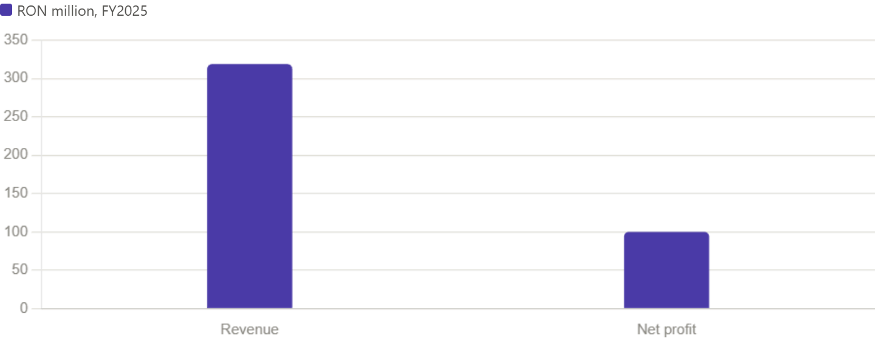
Chart 2: Biofarm 2025 financials. Biofarm is the Romanian pharmaceutical manufacturer Polpharma acquired via a ~€270 million takeover completed in July 2026. Figures are from Biofarm's own reported 2025 results, cited by Romania Insider: revenue of RON 319 million and net profit of RON 100 million (a strong ~31% net margin), giving a sense of the scale and profitability of the asset Polpharma just added to its Central and Eastern European footprint.

References
Access dates reflect when each source was consulted for this report (July 23, 2026).
- Dr. Reddy's Laboratories Ltd, Form 6-K filings (FY2025/FY2026), U.S. Securities and Exchange Commission (SEC EDGAR). sec.gov. Accessed July 22, 2026.
- "Dr Reddy's Laboratories Ltd Full Year 2025 Earnings Call Highlights," Yahoo Finance/GuruFocus, May 12, 2025.
- "Dr. Reddy's Laboratories Ltd Company Profile," GlobalData. globaldata.com. Accessed July 22, 2026.
- "Dr. Reddy's Laboratories (RDY) Revenue 2016-2025," StockAnalysis.com. Accessed July 22, 2026.
- "Dr. Reddy's 2026 Company Profile," PitchBook. pitchbook.com. Accessed July 22, 2026.
- Dr. Reddy's API business pages (api.drreddys.com), including "Dr. Reddy's Presence in the USA" and "Meet our API Pharma Product Experts." Accessed July 22, 2026.
- "Dr. Reddy's Labs receives seven USFDA observations for Hyderabad facility," Business Standard / JM Financial Services, June-July 2026.
- "Dr Reddy's Lab gets EIR from USFDA for Srikakulam facility," Business Standard, March 6, 2026.
- "USFDA Issues 7 Observations To Dr. Reddy's Hyderabad Facility," Republic World, June 26, 2026.
- "Dr. Reddy's Hyderabad Plant Flags 7 USFDA Observations," Sahi.com, June 2026.
- "Dr Reddy's gets 7 USFDA observations after Srikakulam plant inspection," Business Standard, July 20, 2025.
- Dr. Reddy's Laboratories, Wikipedia. Accessed July 22, 2026 (used for general corporate history only, cross-checked against primary sources).
- PharmaCompass, "Dr. Reddy's Laboratories" manufacturer profile. pharmacompass.com. Accessed July 22, 2026.
- "Dr Reddy's Laboratories Limited Announces USFDA GMP Inspection at CTO-5," MarketScreener, May 27, 2025.
- "Dr. Reddy's Laboratories (RDY) Secures License for XACDURO Distribution," GuruFocus, June 20, 2026.
- "RDY - Dr Reddys Labs Latest Stock News & Market Updates," StockTitan. Accessed July 22, 2026.
- "Dr Reddy's Labs shares in focus as pharma major inks $32 million deal," Business Today, February 19, 2026.
- "Dr. Reddy's Lab jumps 2%: Why is this pharma stock rising?" India Infoline, 2026.
- "Dr Reddy's launches Bosutinib 400mg in US, secures exclusivity," ScanX/IQVIA National Sales Perspectives data, June 15, 2026.
- Synapse (PatSnap), PortersFiveForce.com, MatrixBCG.com, Pestel-analysis.com, and KoalaGains.com competitive-landscape profiles of Dr. Reddy's Laboratories. Accessed July 22, 2026.
- "India Pharmaceutical Industry Strategic Landscape Report 2025," ResearchAndMarkets.com, via Yahoo Finance, November 6, 2025.
- "India Pharma Surges 8.6%!" Whalesbook, December 15, 2025.
- "Dr Reddy vs Sun Pharma: Leaders of India's pharma," StockGro, May 22, 2025.
- Polpharma Group B.V., "About Polpharma Group," polpharmagroup.com. Accessed July 22, 2026.
- Polpharma, "Active pharmaceutical ingredients (API)" and "Pharmaceutical Plant in Starogard Gdański," polpharma.pl. Accessed July 22, 2026.
- Polpharma API / CDMO, api.polpharma.com and cdmo.api.polpharma.com. Accessed July 22, 2026.
- "Polpharma has opened the first center in Poland for HP API production," Polpharma press release, polpharma.pl, 2024-2025.
- Polpharma homepage, "Polpharma launches a platform in Starogard Gdański for RNA-based medicines," polpharma.pl, May 20, 2026.
- "Polpharma Strengthens Its Position in Central and Eastern Europe - Biofarm joins the Group," Pressat/news aktuell, July 21, 2026.
- "CMS advises Polpharma on acquisition of Biofarm through voluntary takeover bid," The Diplomat Bucharest and Lawyers Week, July 22, 2026.
- "Board of Romanian pharmaceutical manufacturer Biofarm greenlights takeover by Polish buyer," Romania Insider, May 26, 2026.
- "Romania's Biofarm becomes part of Polish Polpharma," Romania Insider, July 2026.
- "Securing Health and Economy: How Polpharma Group Expands Kazakhstan's Pharmaceutical Industry," Polpharma-Santo. Accessed July 22, 2026.
- "Teva and Polpharma Biologics sign global deal for ocrelizumab biosimilar," Pharmaceutical Technology / Yahoo Finance, July 2026.
- "What the Ocrelizumab Deal Does for the Multiple Sclerosis Biosimilar Pipeline," Pharmaceutical Technology (pharmtech.com), July 2026.
- "Teva and Polpharma Biologics sign global licensing deal for Ocrevus biosimilar candidate," Manufacturing Chemist, July 2026.
- "Key Biosimilars Events of June 2026," PharmaShots, June 2026.
- Polpharma Biologics newsroom, "FDA file acceptance for review of natalizumab" and related release archive, polpharmabiologics.com. Accessed July 22, 2026.
- "2025 Biologics & Biosimilars Landscape: IP, Policy & Market Trends," Fish & Richardson (fr.com), March 9, 2026.
- ZoomInfo company profiles: Polpharma, Polpharma Group, Polpharma Biologics. zoominfo.com. Accessed July 22, 2026.
- PitchBook, Tracxn, LeadIQ, and Preqin company profiles of Polpharma / Zakłady Farmaceutyczne Polpharma S.A. Accessed July 22, 2026.
- "Poland: A Sleeping Giant," PharmExec, March 19, 2026.
- Adamed Pharma company profile, IntuitionLabs.ai. Accessed July 22, 2026.
- "3 Generic Drug Stocks to Watch," Zacks Investment Research (via Yahoo Finance) and Morningstar, 2025-2026.
- "Zacks Industry Outlook Highlights Teva Pharmaceuticals, Sandoz and Dr. Reddy's," Yahoo Finance, March 5, 2026.

